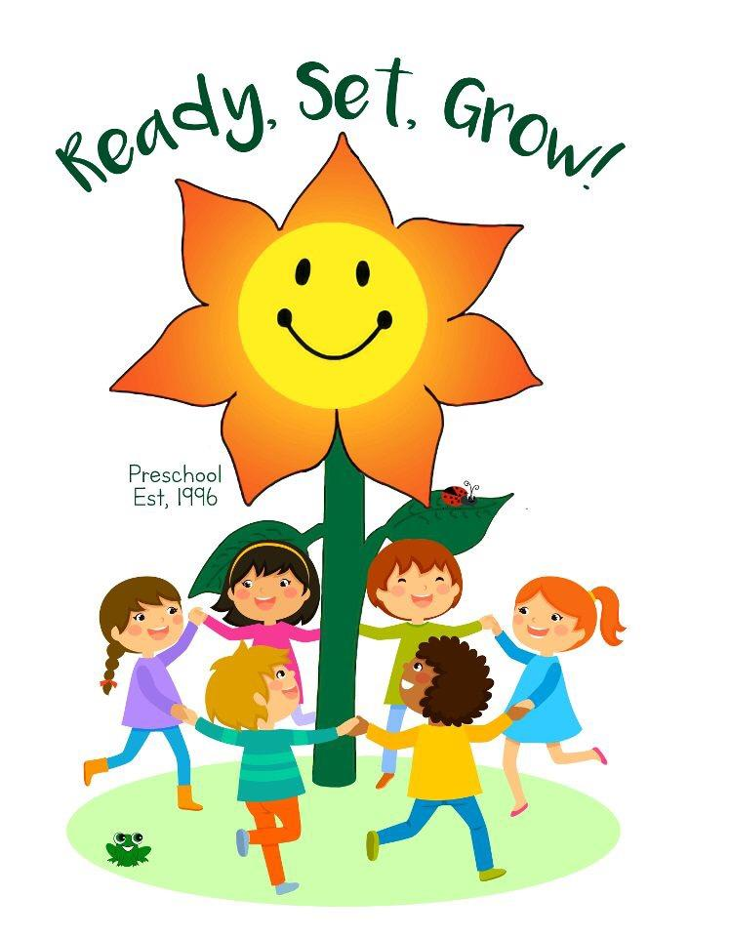
Thank you for considering

Ready, Set, Grow! Preschool

Our Mission is to create an environment of learning for both parents and children that strengthens the relationship between each other, their neighbors, and their community.

We are a non-profit, cooperative preschool!

A co-op preschool provides parents with the opportunity to be actively involved in their child’s first educational experience. A qualified teacher leads the classroom, while parents and caregivers volunteer their time and talent to the school. Each family shares in the business operation of the school and assists the teacher in the classroom on a rotating basis. This creates a loving atmosphere where children, teachers, and parents grow, develop, and learn together.

3’s Classes:
Must be 3 years old by December 1st.
Tuesday and Thursday
Blue Monkeys AM Class: 8:20am-11:00am
Green Monkeys PM Class 12:00pm- 2:40pm
Tuition $165 per month*
4’s Classes:
Must be 4 years old by December 1st.
Monday, Wednesday & Friday
Red Bears AM Class: 8:20am- 11:00am
Purple Bears PM Class: 12:00pm- 2:40pm
Tuition $195 per month*

Our program is committed to the belief that children build confidence, joy, and independence through respect, love, and a strong sense of self.

We focus on development by:

- Providing hands on experiences through arts & crafts activities, play dough, music activities, science and cooking.
- Open play and structured playground and team activities.
- Presenting problem-solving techniques that hone children’s critical thinking skills to build a better self-concept within a positive atmosphere.

As a cooperative preschool, we are able to keep costs low by the involvement and commitment of our parents and/or caregivers. Requirements include:

- Volunteering in the classroom to assist the teacher 2 or more times a month.
- Attend a (fun!) monthly parent meeting, which are required by licensing, and are a great way to stay informed about what is happening at RSG! They are via Zoom on the first Thurs of the month.
- Participate in fundraisers!
- Perform assigned parent jobs (ex. Arts & crafts, party planning, etc)
- Serve on two committees or head one committee (ex. Holiday program, yearbook, fundraising) (Only one committee required at this time)

Enrollment Process:

- Meet with our membership coordinator to tour the school and learn about RSG!
- Secure your child’s spot in a class by paying an $85 non-refundable enrollment fee.*
- Receive and complete enrollment packet
- Attend enrollment day (end of August)
  - Pay first and last month’s tuition
  - Submit Completed Enrollment Paperwork

*Please note: RSG has a no cash policy. We accept personal checks or money order (made out to Ready, Set, Grow or RSG), or you may pay through Venmo (@readysetgrow2019)

In order to begin classes with RSG, forms required by the state of California and RSG must be submitted. This is not a complete list, only an overview. All required forms will be included in the enrollment packet. You may attend a trial class without the required forms, but forms will be due the following class.

Requirements for student:
- Physicians Report (completed by child’s physician)
- Immunization Records in accordance with the standards of SB277
- Health History
- Emergency Information and Consent Forms

Requirements for working parent:
- Live Scan**
- TB test (within last 15 months)
- Proof of Vaccinations or blood test proving immunity
  - MMR
  - TDAP (within last 5-10 years)
  - Flu vaccine or declination form
**Your enrollment packet will contain the instructions for completing your Livescan, including information on where to find locations and cost. Please ensure you have completed your Livescan before your child starts school.

Fundraising:
Each family has a yearly $250 fundraising quota (if you are not enrolling at the beginning of the school year, this amount will be prorated for the number of months that you attend RSG at $25 per month) We have many opportunities to raise money at fundraising events throughout the school year, or you may pay this monthly, or all at once.

Things that your child will need for school:
- Bucket (small, moping style)
- Lunchbox with a snack
- Water bottle

- Change of clothes
  - Please put in a clear bag to leave at school
Why do they need a bucket? Buckets are easier for our students to use than backpacks, and you are free to personalize the bucket, and add their name in big letters! Any bucket that can fit their lunch box, water bottle, and finished projects that are sent home. Snack guidelines can be found in the parent handbook,
We look forward to welcoming you as a part of the Ready Set Grow family.

